Shawnee Guided
Hiking Tours & Shuttle Service by Bart Lane
On 210 Indian Kitchen Rd near Eddyville IL, adjacent to the Lusk Creek Wilderness Area and on past the Dead End sign you will encounter a new sign.
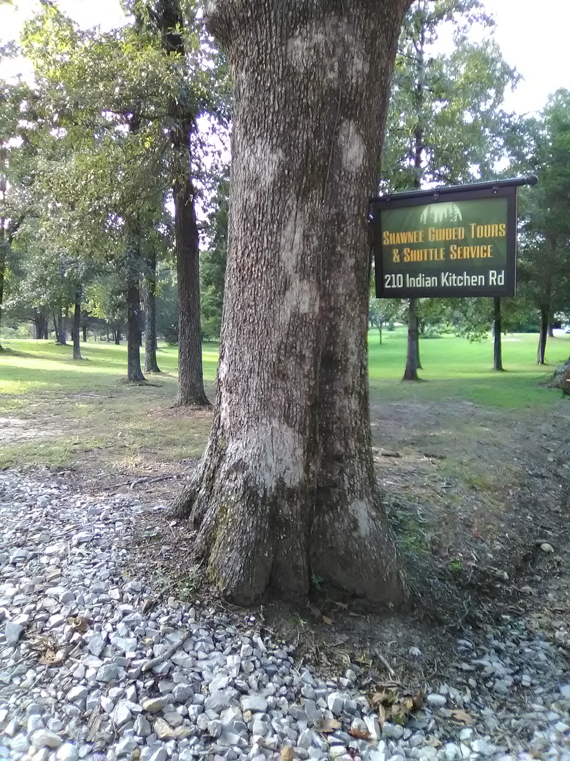
Shawnee Guided Tours & Shuttle Service hangs from a large oak tree in front of Bart and Carol Lane’s home. The house may be new but the property that is nestled between the Lusk Creek Wilderness Area and Bear Branch in the Shawnee National Forest has been home to Bart’s family for more than 60 years. The trails along the bluffs and creeks leading to Lusk Creek Canyon/Indian Kitchen Natural Area is where Bart spent his childhood hiking, exploring, canoeing, and later guiding trail riders on horseback. He gained a much broader knowledge of the trails throughout the SNF during his 8 years as owner of Bay Creek Ranch Horse Camp. During that time he not only lead trail rides but worked alongside the US Forest Service mapping out and ensuring that many of the existing trails connect and remain open for equestrian use, and according to Ranger at the time Tim Poulman, was instrumental in the implementation of the equestrian trail system now in place.

Bart has worked as a laborer, operator, horse camp owner/trail guide with wife Carol, and after several job opportunities fell through he took it as a sign and decided to go back out on his own to do what he does best, and that is to guide others to places and experiences they would not find on their own. “My wife Carol and I would hike to a beautiful overlook or along a bluff line and talk about how so many people would enjoy being here away from all the noise and traffic and commotion of everyday living, and we would wish we could figure out a way to help bring them here and still be able to sustain ourselves enough to remain free to do so,” says Bart. So at a point where it was time to follow his dream or let it go, he obtained his Outfitter/Guide Permit from the US Forest Service and began Shawnee Guided Tours & Shuttle Service.
“What I hope to achieve through my services is an opportunity to take individuals and groups of hikers that would benefit from being guided along unfamiliar trails to places they would not see on their own” Bart states. “The shuttle service is another way to help hikers enjoy their experiences more conveniently. It allows, for example, River to River thru hikers or day hikers to travel here in one vehicle. I pick them up at a designated point, usually where they plan to end up and leave their car, and take them to their starting point. Once I do this they are on my radar so to speak and I am available to come and get them off the trail if needed. My shuttle service also offers for those staying in local cabins and lodging to be picked up, driven to (mostly along scenic back roads), and guided on a hike of their choosing. The shuttle service is not limited to hikers. Those coming to kayak the area creeks, Lusk, Bear Branch, Grand Pierre, etc, can also benefit from the convenience of bringing one vehicle and getting delivered to their starting point. “The new steps that have been put in on the Eddyville Rd by the iron bridge gives better access to Lusk Creek for canoeing and kayaking.”explains Bart.

In addition to these services and because of the proximity to the River to River
Trail and direct access to Lusk Creek Wilderness Area Trail System, Bart has opened his home to River to River hikers as a Way Station. He offers primitive camping, shelter if needed, water, WiFi, a small private lake for relaxing or fishing, package/supply delivery or pick up, and shuttle service back to the River to River trail. “It’s a great place to regroup and recharge about half way along the journey,” says Bart, “and if you ask nicely Carol will happily share her laundry facility.”

One thing Bart stressed is there are a lot of beautiful areas to visit such as Garden of the Gods, Dixon Springs State Park, Rim Rock to name a few with easy marked trails, many of which are rocked or paved and they are a great way to see some of the highlights of the SNF on your own. However the trails and areas he likes to travel are much more rugged and less visited. “They are not a walk in the park,”says Bart, “many of the trails are unmarked and require a certain amount of physical endurance and ability. These are the trails that lead to many of the hidden wonders in the SNF and when you get to these destinations you truly experience a sense of adventure as well as the discovery of their beauty.” 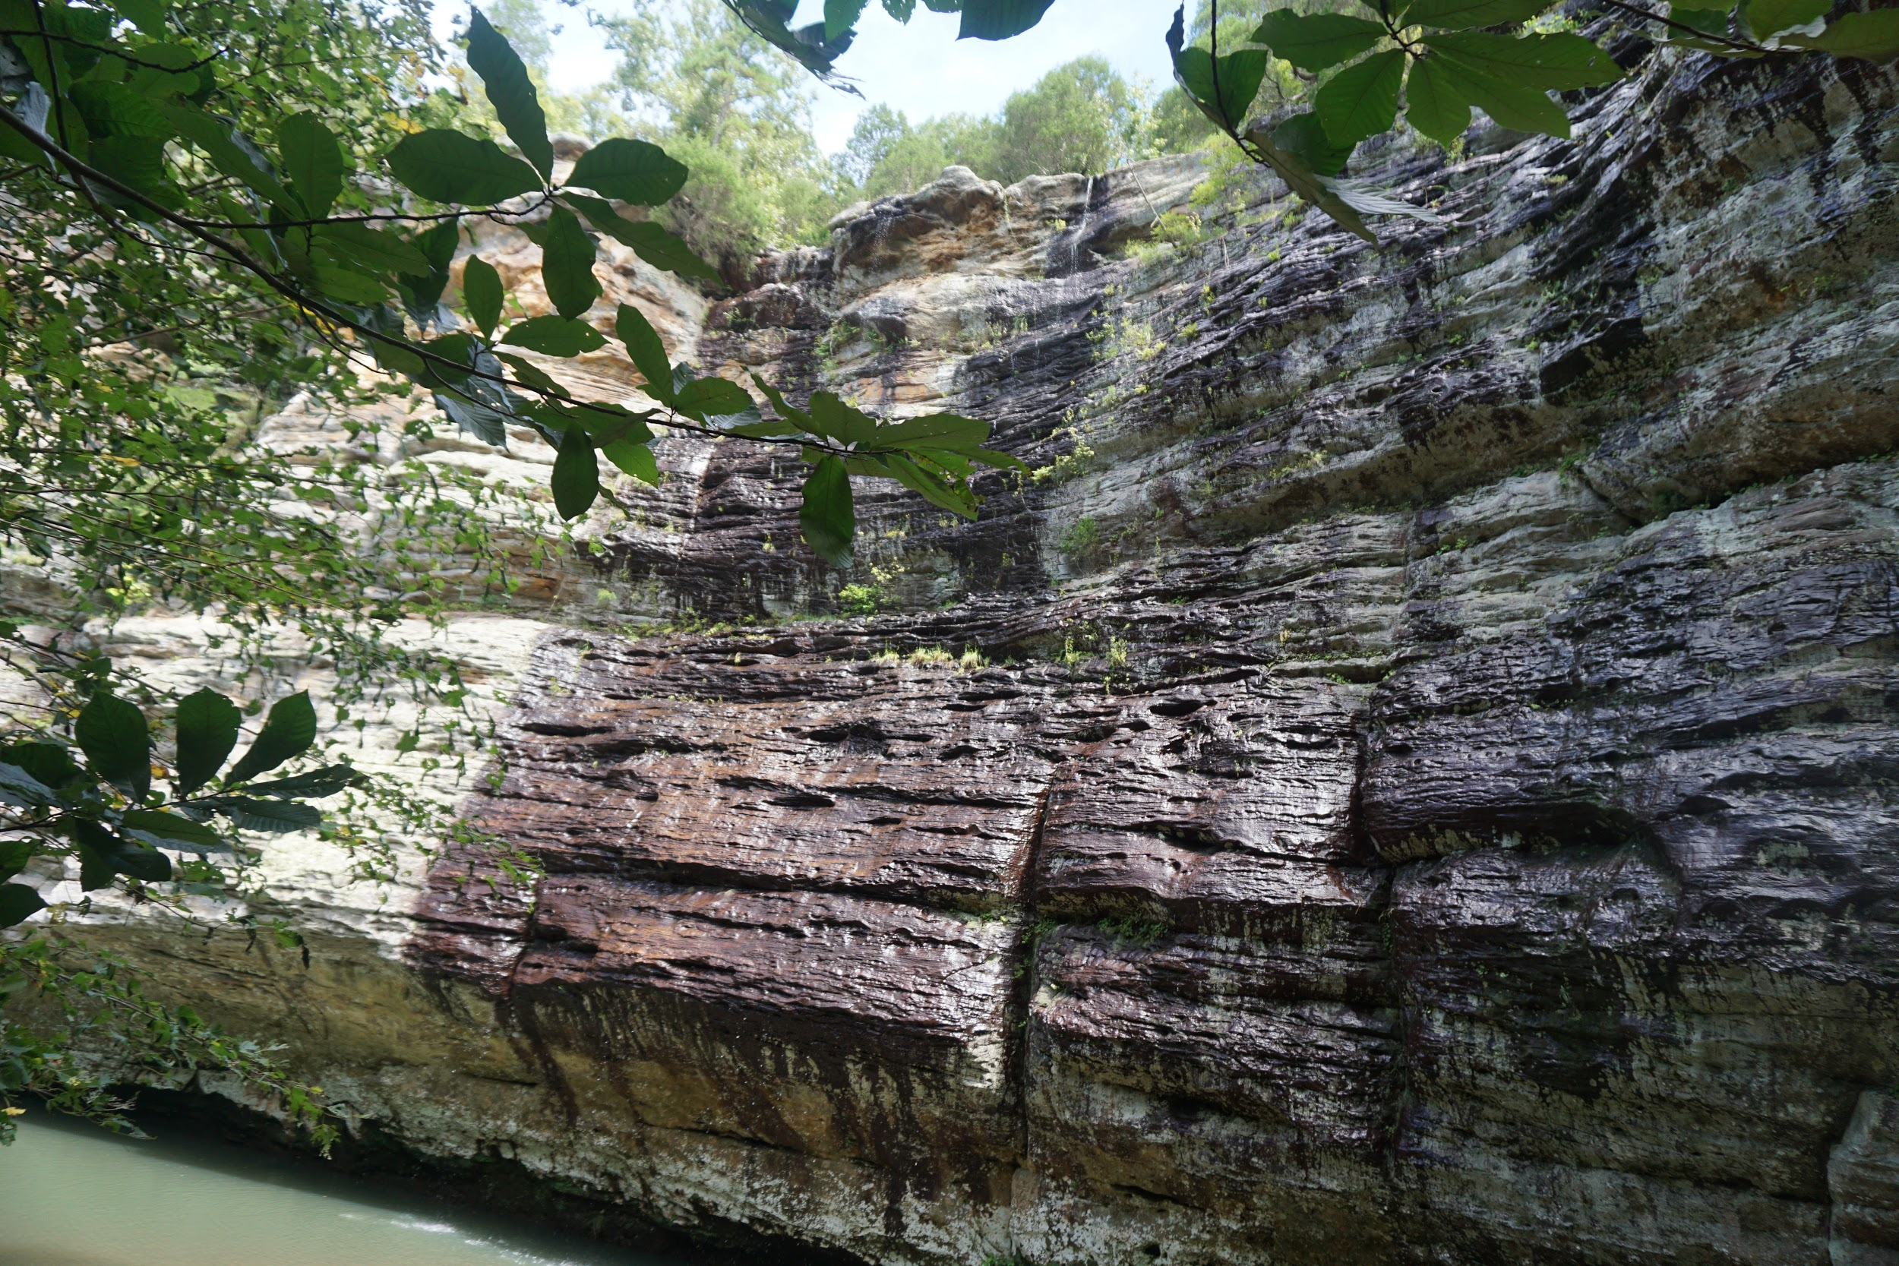
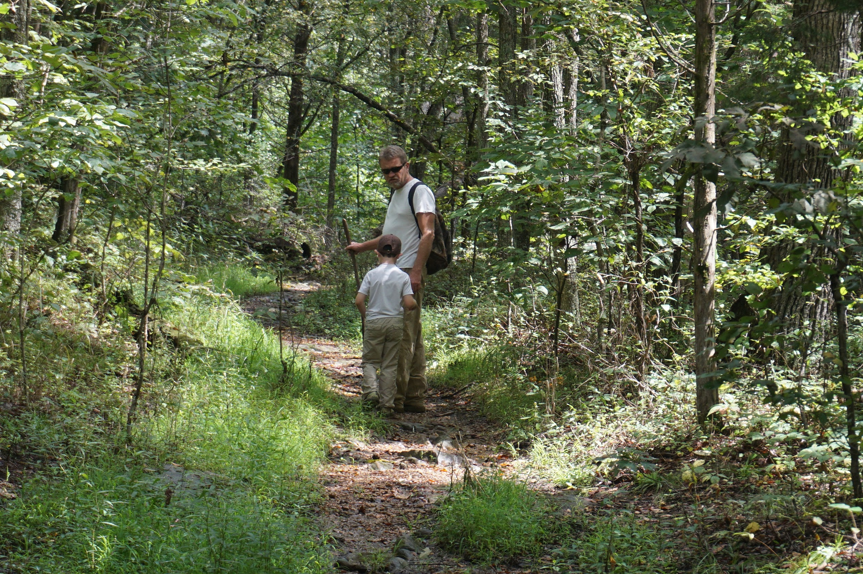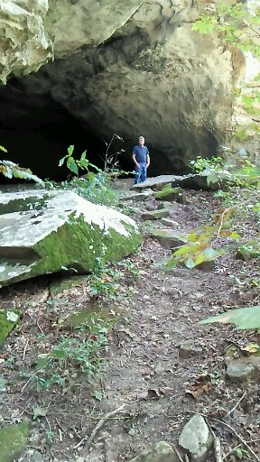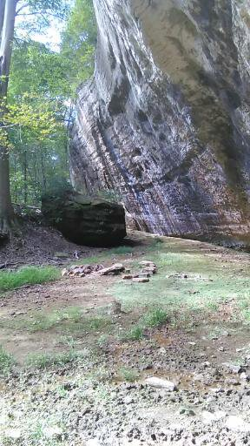

Bart always recommends that you be properly prepared for his hikes by wearing sturdy boots or hiking shoes, appropriate clothing, bring plenty of water, and often a hiking pole or stick is useful in crossing creeks and navigating rocky terrain. Hikers also need to be prepared for seasonal challenges, bugs in the summer, inclement weather in the winter. Children are welcome and encouraged to share the experience as long as they can handle the length of the hike, and dogs on leash can always be a part of the journey.

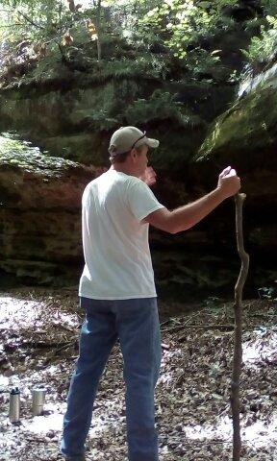
Bart’s charm is in the entertaining telling of his many adventures, his witty words of wisdom, and his straight up grass roots outlook on life that resonates with his spirit of adventure.

“There is much to be gained from a walk in the woods.”

“My wife Carol and I have always found solace from the worries of everyday life in the woods. There is something to be said about the benefits of Forest Bathing. When you go deep enough in the woods you leave everything else behind. Everything you see, hear, and feel is God’s creation and you realize by your own appreciation that you belong here too.”

If you would like to experience a walk in the woods but are not sure where to go, let Bart lead the way.
If you are planning your River to River thru hike, let Bart help with the logistics of your trip and enjoy the convenience of being shuttled from your car to the starting point of your hike.

Open Year Round
USDA Federally Licensed
Family Outings
Private Group Hikes
Customized Hikes
Scheduled Event Hikes
Half Day Wilderness Treks
Shuttle Service Throughout the SNF
Contact Bart for details regarding rates and dates for scheduled events:
PH: 618 672-1027
Email: bartlane210@gmail.com
fb: @shawneehikingtours
Located at 210 Indian Kitchen Rd, Eddyville, IL

