Apple Gift Boxes $19.⁰⁰
Here is an easy, affordable way to show your appreciation to anyone who deserves special thanks this season. This handsome gift box is filled with 22 of our largest, sweetest, and most impressive apples, picked at their peak, then hand packed into a nest of finely shredded aspen. Everyone who receives this surprise will be delighted with the flavor-packed, good-for-you fruit.
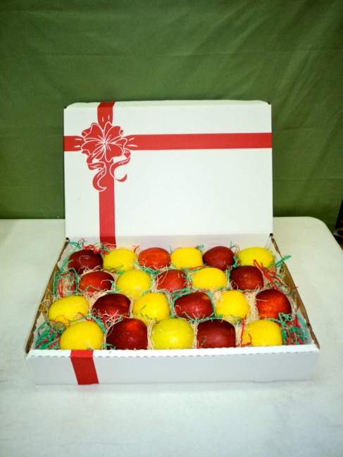
About Us
Nestled in the hills of Southern Illinois' Shawnee National Forest is Rendleman Orchards. Since 1873, Rendleman Orchards has been committed to growing and shipping quality peaches, nectarines, apples and vegetables to the commercial produce markets throughout the Midwest. Rendleman Orchards is proud to be an Illinois Centennial Farm. This year, we are celebrating our 141st year of family farming!
During harvest season, which runs from July to December, Rendleman Orchards Farm Market offers our fine fruits, fresh vegetables and many other unique products. During apple season, we offer apple cider slushes, made using our own tree ripened apples. Many of our weekend visitors stop by for these alone, but stay to do some shopping and chat with our friendly staff. We’re located just a short, scenic drive from Carbondale, Illinois, and Cape Girardeau, Missouri, on Illinois Route 127 one mile north of Alto Pass, IL.

Farm Market Hours:
July – December: Mon.-Sat. 9am-5pm. Sun. 12pm-5pm.
January – June: Market Closed for winter season.

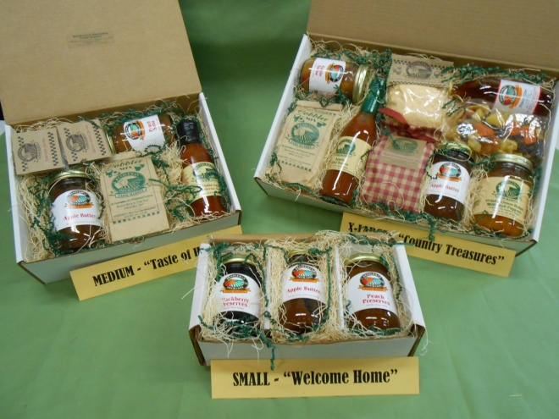
Our most popular GIFT BOXES. All of our Gift Boxes are available for shipping. Please call to place your order.
The last date for shipping is 12/15/14.

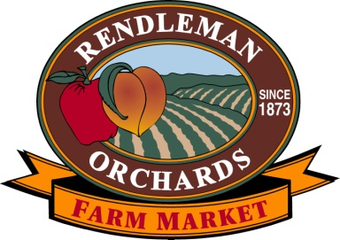
9680 State Route 127 North
Alto Pass, IL 62905
Phone: 618.893.2771
Fax: 618.893.2370
info@rendlemanorchards.com
www.rendlemanorchards.com
www.facebook.com/RendlemanOrchards

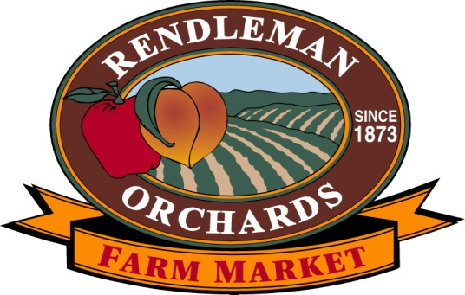

Local Gift Baskets

and

Gift Boxes Shipped!
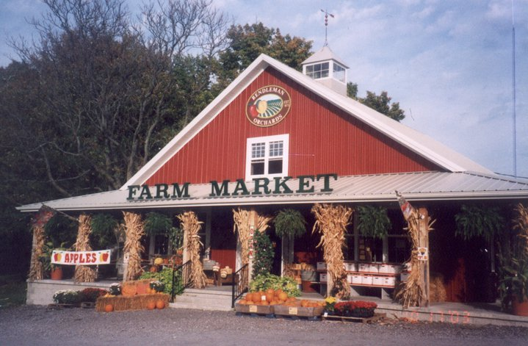
ILLINOIS CENTENNIAL FARM
100 YEARS Recognition
Rendleman Orchards is proud to be an Illinois Centennial Farm. We are now celebrating 141 years of family farming.

Presentation Gift Baskets
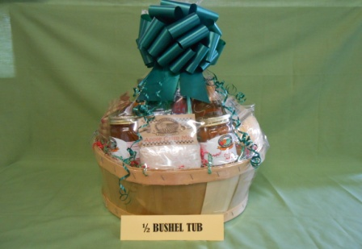
The Half Bushel Gift Basket contains pasta sauce, Amish noodles, apple butter, salad dressing, BBQ sauce, relish, syrup, snacks, salsa, preserves, 5 baking mixes, and medium cider for $85.75.
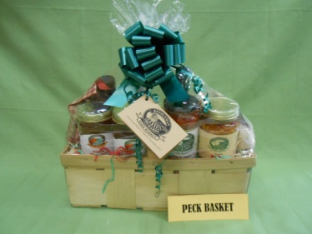
The Peck Basket contains apple butter, preserves, salsa, relish, medium cider, BBQ sauce, salad dressing, 2 baking mixes and a snack for $55.50.
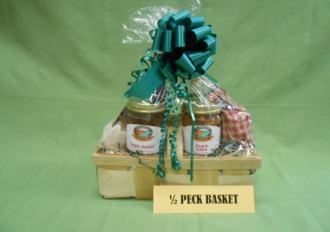
The ½ Peck Basket contains, apple butter, BBQ sauce, salsa, cider and 2 baking mixes for $33.00.
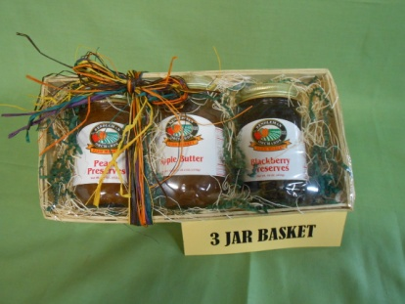
The 3 Jar Basket contains apple butter and 2 preserves for $20.25.

The 2 and 3 jar Saluki Gift boxes are $17.50 and $22.50.
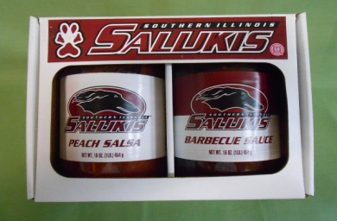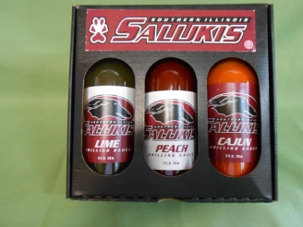
Gift Boxes for Shipping
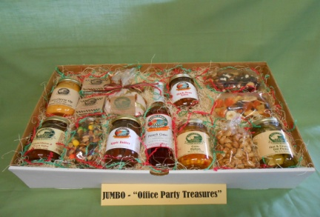
The Jumbo Gift Box “Office Party Treasures” contains 2 salsas, pickles, relish, cheese dip, apple butter, medium cider, 2 dip mixes, and 5 snacks for $84.75.
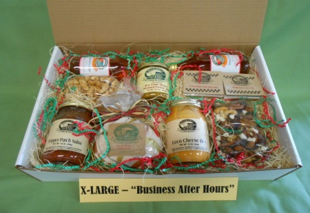
The Extra Large “Business After Hours” Gift Box contains 2 jars of dip, salsa, cappuccino mix, 3 snacks, 2 ciders, and 2 dip mixes for $54.00.
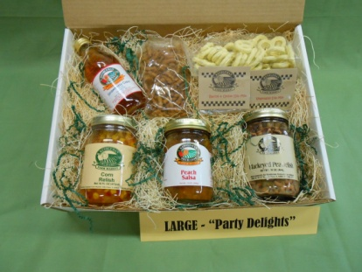
The Large “Party Delights” Gift Box contains 2 jars of relish, salsa, cider, 2 bags of crunchy snacks and 2 dip mixes for $39.50.
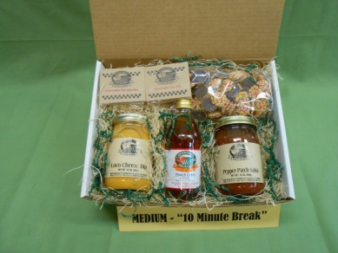
The Medium “10 Minute Break” Gift Box contains cheese dip, salsa, 2 dip mixes, cider and a bag of snacks for $29.25.

Create Your Own!
We will be happy to consult with you to customize a Gift Basket or Gift Box. All of our Gift Boxes can be shipped. Shipping costs will vary by location.

Gift Boxes for Shipping
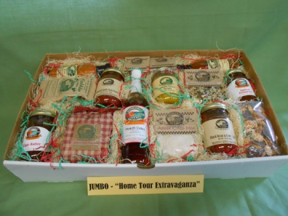
The Jumbo Gift Box “Home Tour Extravaganza” contains apple butter, cider, pasta sauce, relish, salad dressing, preserves, 2 salsas, 2 dip mixes, 3 baking mixes, a soup mix and a snack for $76.75.
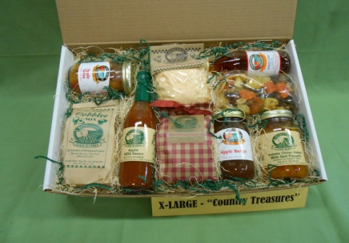
The Extra Large “Country Treasures” Gift Box contains Apple Butter, salsa, BBQ sauce, soup mix, baking mixes, relish, cider and fruit snack mix for $52.00.
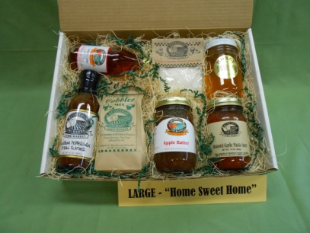
The Large “Home Sweet Home” Gift Box contains apple butter, pasta sauce, steak slather, honey, cobbler mix, soup mix, and cider for $39.25.
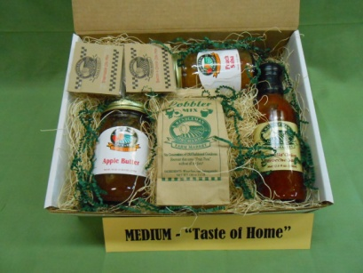
The Medium “Taste of Home” Gift Box contains apple butter, salsa, BBQ sauce 2 dip mixes and cobbler mix for $27.00.

The 3 jar “Welcome Home” and “Country Sampler” Gift Boxes are $20.50 and $23.50.
